Tanish M 1BM26CS525-T SECTION “Q”

INSURANCE DATABASE

1) Create a Database called “INSURANCE DATABASE”
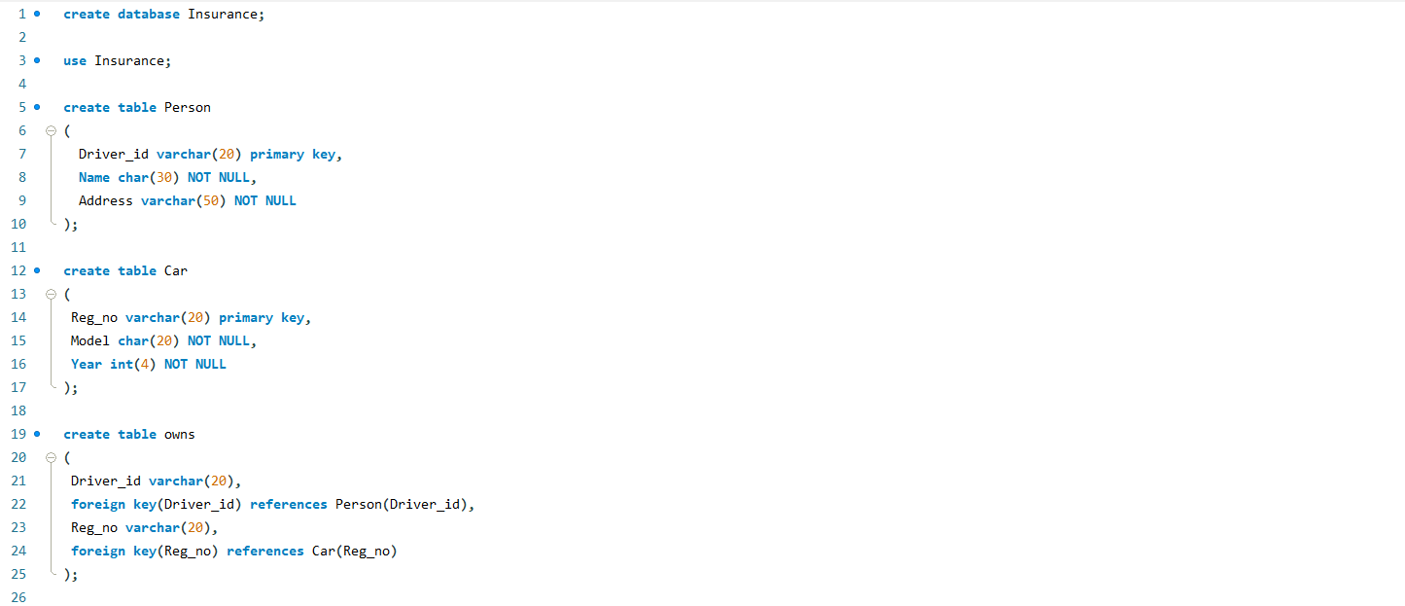
2) Create the above tables by properly specifying the primary keys and the foreign keys.
- Person table
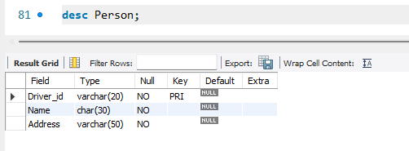
- Car table
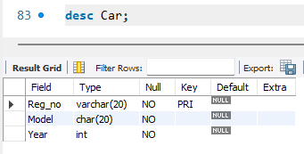
- Owns Table
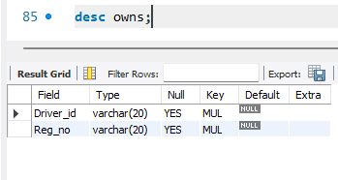
- Accident table
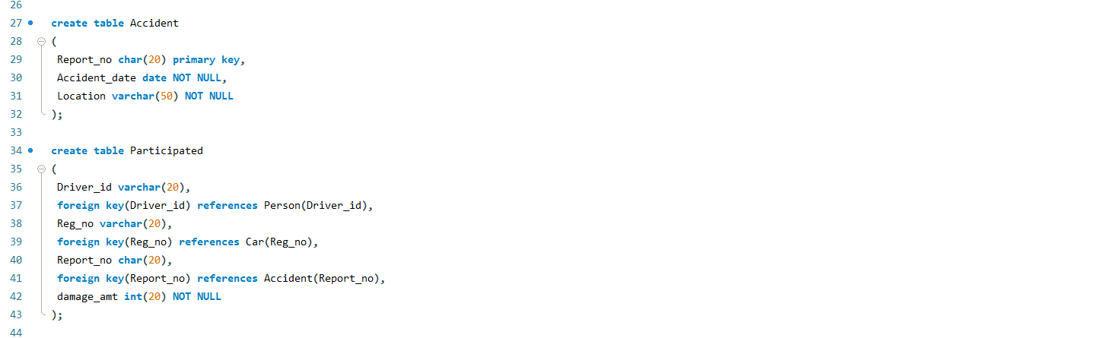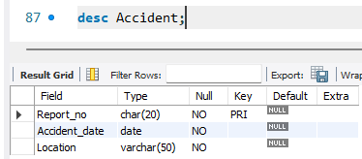
- Participated
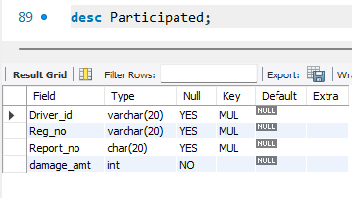
3) Enter at least five tuples for each relation.
- Person table
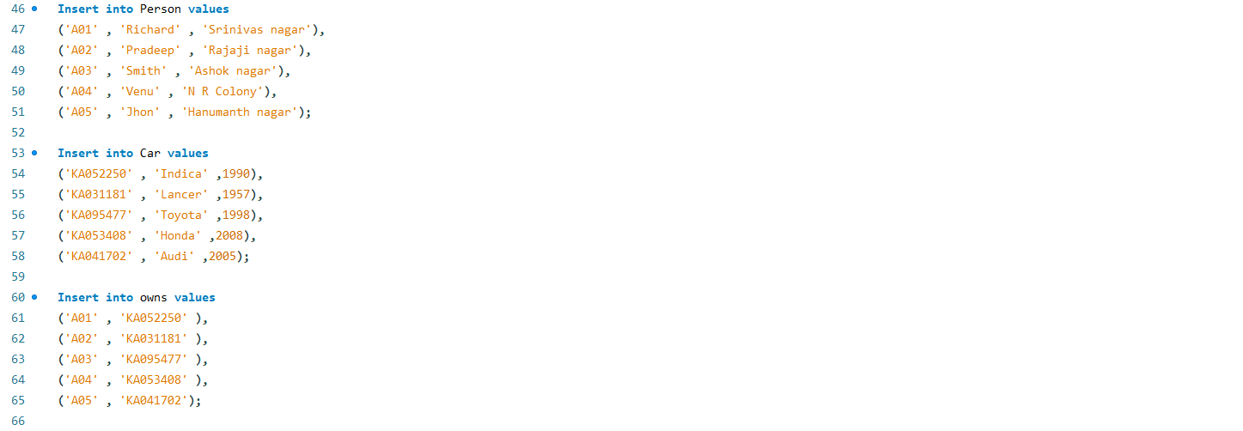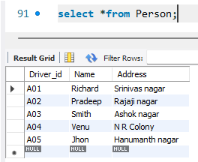
- Car table
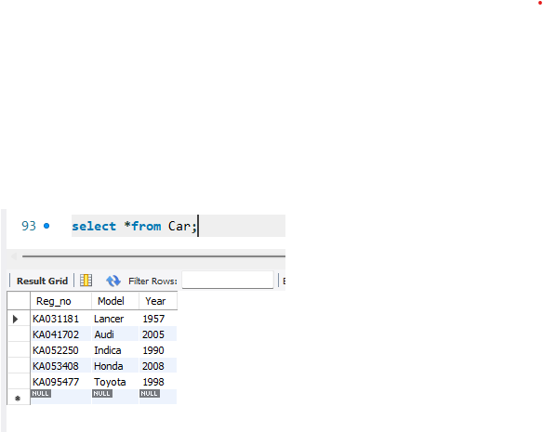
- Owns table
- Accident table
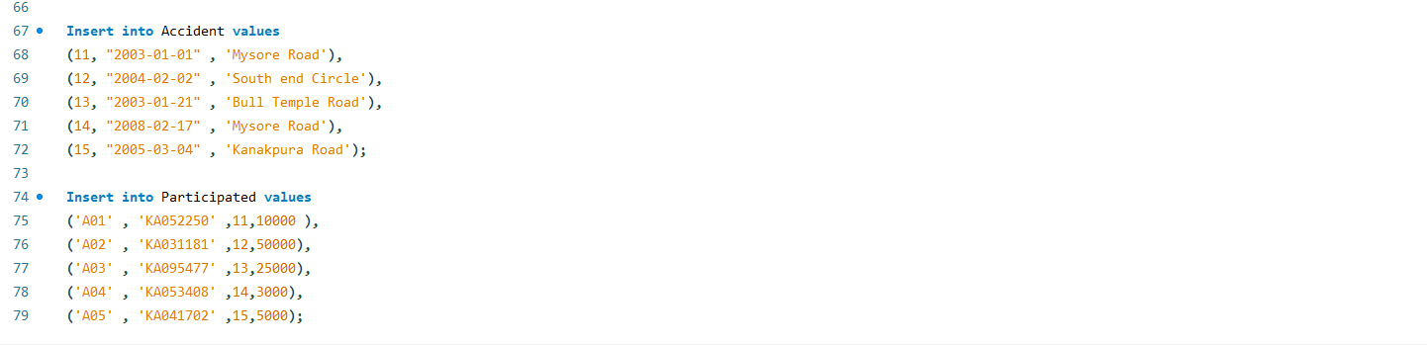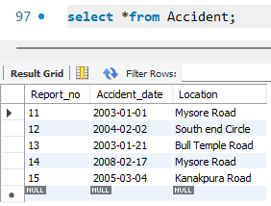
- Participated
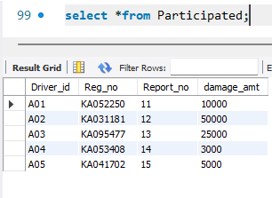
4) Update the damage amount to 25000 for the car with a specific reg_num
(example: &#39;KA053408&#39;) for which the accident report number was 12.
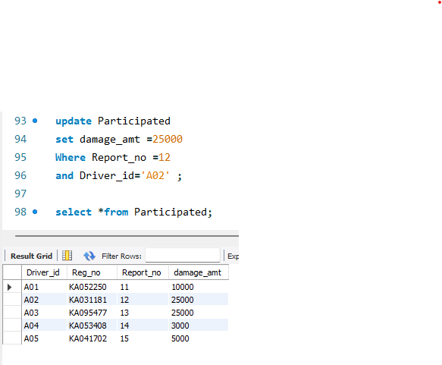

5) Add a new accident to the database.
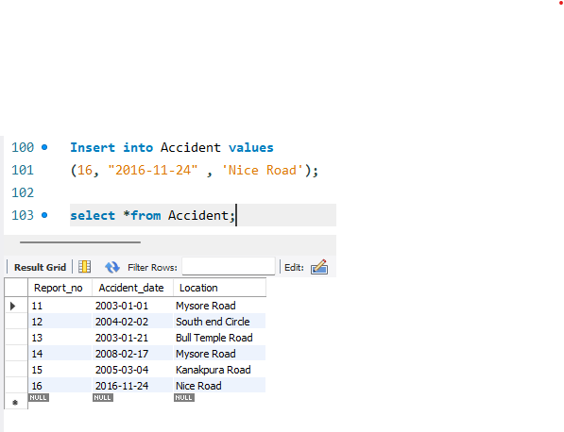

6) Display Accident date and location
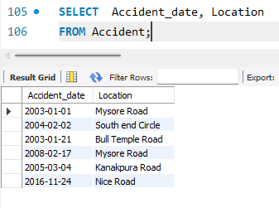

7) Display driver id who did the accident damage greater than or equal to Rs.25000.
